Pascal's Triangle

Definition
# Source: AI Source: Provided by: [Data Path: Persons Table -> ID Column: 1, Name_En Column: Motasem Essam] -> From: [ChatGPT] on [7/11/2026]
Pascal's Triangle is a triangular arrangement of numbers in which each number is the sum of the two numbers directly above it. The numbers along the edges are always 1.
It is named after the French mathematician Blaise Pascal, although the triangle was known centuries earlier in China, India, Persia, and the Islamic world.

Construction Rule
# Source: AI Source: Provided by: [Data Path: Persons Table -> ID Column: 1, Name_En Column: Motasem Essam] -> From: [ChatGPT] on [7/11/2026]
Pascal's Triangle is built using the following rules:
- The top row contains a single 1.
- Every row begins and ends with 1.
- Every interior number equals the sum of the two numbers directly above it.
Mathematically:
$$T\left(n , k\right)=T\left(n-1 , k-1\right)+T\left(n-1 , k\right)$$
where:
- $T\left(n , k\right)$= value at row $n$, position $k$.

Pascal's Triangle
# Source: AI Source: Provided by: [Data Path: Persons Table -> ID Column: 1, Name_En Column: Motasem Essam] -> From: [ChatGPT] on [7/11/2026]
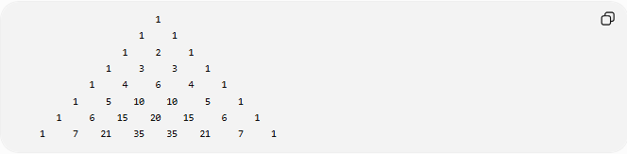
1
1 1
1 2 1
1 3 3 1
1 4 6 4 1
1 5 10 10 5 1
1 6 15 20 15 6 1
1 7 21 35 35 21 7 1

First Rows
# Source: AI Source: Provided by: [Data Path: Persons Table -> ID Column: 1, Name_En Column: Motasem Essam] -> From: [ChatGPT] on [7/11/2026]
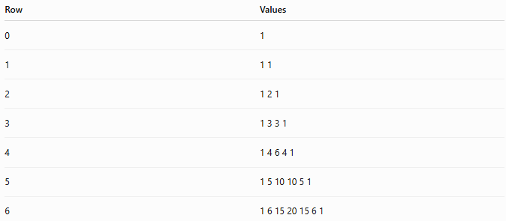
Row | Values
0 | 1
1 | 1 1
2 | 1 2 1
3 | 1 3 3 1
4 | 1 4 6 4 1
5 | 1 5 10 10 5 1
6 | 1 6 15 20 15 6 1

Properties
# Source: AI Source: Provided by: [Data Path: Persons Table -> ID Column: 1, Name_En Column: Motasem Essam] -> From: [ChatGPT] on [7/11/2026]
1. Edge Property
The first and last numbers of every row are:
$$1$$

2. Addition Property
Each interior value equals:
$$\text{Left Above}+\text{Right Above}$$
Example:
$$10=4+6$$

3. Symmetry Property
Each row is symmetric.
Example:
$$1, 5, 10, 10, 5, 1$$
reads the same from both directions.

4. Row Sum Property
The sum of the numbers in row $n$is:
$$2^{n}$$
Examples:
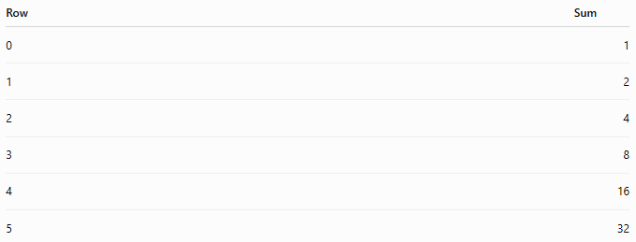
Row | Sum
0 | 1
1 | 2
2 | 4
3 | 8
4 | 16
5 | 32

5. Diagonal Patterns
Different diagonals generate famous number sequences.
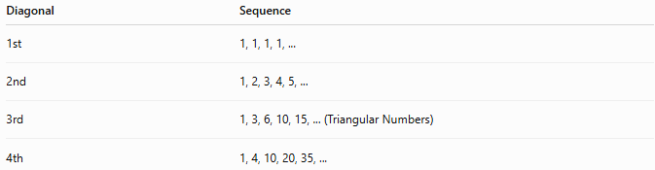
Diagonal | Sequence
1st | 1, 1, 1, 1, ...
2nd | 1, 2, 3, 4, 5, ...
3rd | 1, 3, 6, 10, 15, ... (Triangular Numbers)
4th | 1, 4, 10, 20, 35, ...

Relationship to Binomial Coefficients
# Source: AI Source: Provided by: [Data Path: Persons Table -> ID Column: 1, Name_En Column: Motasem Essam] -> From: [ChatGPT] on [7/11/2026]
Each entry equals a binomial coefficient:
$$\left({n \atop k}\right)$$
Thus, row $n$contains:
$$\left({n \atop 0}\right),\left({n \atop 1}\right),\left({n \atop 2}\right),…,\left({n \atop n}\right)$$

Examples
# Source: AI Source: Provided by: [Data Path: Persons Table -> ID Column: 1, Name_En Column: Motasem Essam] -> From: [ChatGPT] on [7/11/2026]
Example 1
Find the next row after:
$$1, 4, 6, 4, 1$$
Next row:
$$1, 5, 10, 10, 5, 1$$

Example 2
Complete the row:
$$1, 6, ?, 20, 15, 6, 1$$
Missing value:
$$15$$
Completed row:
$$1, 6, 15, 20, 15, 6, 1$$

Applications
# Source: AI Source: Provided by: [Data Path: Persons Table -> ID Column: 1, Name_En Column: Motasem Essam] -> From: [ChatGPT] on [7/11/2026]
Pascal's Triangle is used in:
- Arithmetic
- Algebra
- Binomial Expansion
- Combinatorics
- Probability
- Number Theory
- Computer Science
- Statistics
- Discrete Mathematics

Key Points
# Source: AI Source: Provided by: [Data Path: Persons Table -> ID Column: 1, Name_En Column: Motasem Essam] -> From: [ChatGPT] on [7/11/2026]
- Begins with a single 1.
- Every row starts and ends with 1.
- Every interior value equals the sum of the two numbers above it.
- Row $n$sums to:
$$2^{n}$$
- Each value is a binomial coefficient:
$$\left({n \atop k}\right)$$
- The triangle contains many important number patterns and mathematical relationships.

Conclusion
# Source: AI Source: Provided by: [Data Path: Persons Table -> ID Column: 1, Name_En Column: Motasem Essam] -> From: [ChatGPT] on [7/11/2026]
Pascal's Triangle is one of the most important numerical patterns in mathematics. Constructed by repeatedly adding adjacent numbers from the previous row, it reveals deep relationships between arithmetic, combinatorics, probability, and algebra. Each row corresponds to the binomial coefficients used in the Binomial Theorem, while its diagonals generate well-known number sequences such as the triangular numbers. Pascal's Triangle is widely used in arithmetic, algebra, combinatorics, probability, statistics, computer science, and number theory.

